How it works...

The previous code will check whether the current request is AJAX. If it is, it will respond to this request by running the validation and returning the errors in JSON format.

You can check the response from the server in the debug panel in the browser. Try to submit an empty form and you will see the response.

For example, in the Google Chrome browser, press F12 and select the Network tab in the development toolbar. You will see the JSON array with errors and messages:

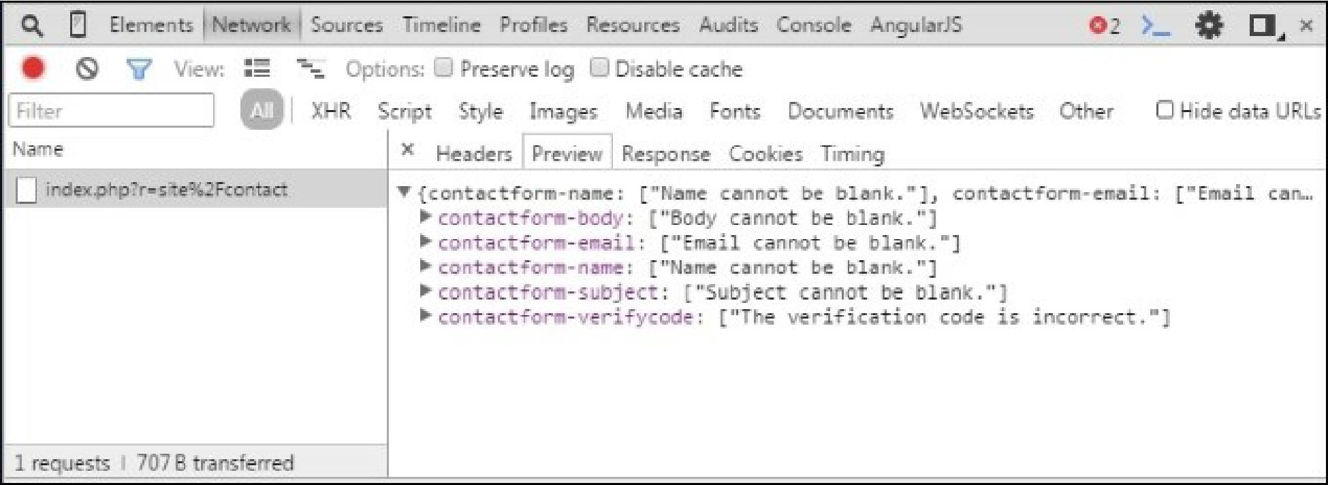

See also

[http://www.yiiframework.com/doc-2.0/guide-input-validation.html#ajaxvalidation](http://www.yiiframework.com/doc-2.0/guide-input-validation.html%23ajaxvalidation)